DATABASE DOCUMENTATION

Purpose: The aviatest_english database contains five tables. These tables contain the cards for the Flash Cards, Memory Game and Quiz. The cards are an image or words (memory game), with audio of the term and a sentence description.

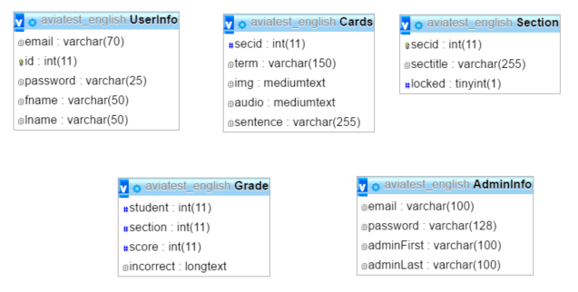

|  |  |  |  |  |
| --- | --- | --- | --- | --- |
| UserInfo |  |  |  |  |
| FIELD NAME | **TYPE** | **DESCRIPTION** | **LIMITS** | **EXAMPLE** |
| id | int(11) AUTO_INCREMENT | Sequential numbering from 1 | Unique numbers | 1, 2, 3, etc. |
| email | varchar(70) | Takes up to 70 characters for an email |  |  |
|  |  |  |  |  |
|  |  |  |  |  |
|  |  |  |  |  |

DATABASE NAME

aviatest_english

DATABASE SCRIPT TO CREATE TABLES

CREATE TABLE UserInfo (  
email VARCHAR(70) NOT NULL,  
id INT NOT NULL AUTO_INCREMENT,  
password VARCHAR(25) NOT NULL,  
fname VARCHAR(50) NOT NULL,  
lname VARCHAR(50) NOT NULL,  
  
PRIMARY KEY (id)  
)  
  
CREATE TABLE Grade (  
student INT NOT NULL references UserInfo(id),  
section INT NOT NULL references Section(secid),  
score INT,  
incorrect LONGTEXT(max)  
)  
  
CREATE TABLE Section (  
secid INT NOT NULL AUTO_INCREMENT,  
sectitle VARCHAR(255),  
locked TINYINT(1) DEFAULT '1',  
  
PRIMARY KEY (secid)  
)  
  
CREATE TABLE Cards (  
secid INT(11) NOT NULL refrences Section(secid),  
term VARCHAR(150),  
img MEDIUMTEXT,  
audio MEDIUMTEXT,  
sentence VARCHAR(255)  
)